

**General Overview**

HDFC Bank Ltd. is one of India’s leading private banks and was among the first to receive approval from the Reserve Bank of India (RBI) to set up a private sector bank in 1994. It is a publicly held banking company, the bank was incorporated in August 1994 under the name of “HDFC Bank Limited”, with its registered office in Mumbai, India. The Bank was promoted by the Housing Development Finance Corporation, a premier housing finance company in India.

It has its presence both on the domestic and international grounds; providing a wide range of financial products and services mainly Retail Banking, Wholesale Banking and Treasury among others to its 5.6 crores customers across different cities in India and also in the world. Along with this, HDFC Bank also has a banking network of 5,779 branches and 17,238 ATMs in 2,956 cities/towns.

**Shareholding Pattern of the Company**

The Shareholding Pattern page of HDFC Bank Ltd. presents the Promoter's holding, Foreign Institutions Investment’s(FII) holding, Domestic Institutions Investment’s(DII) holding, and Shareholding by general public etc.

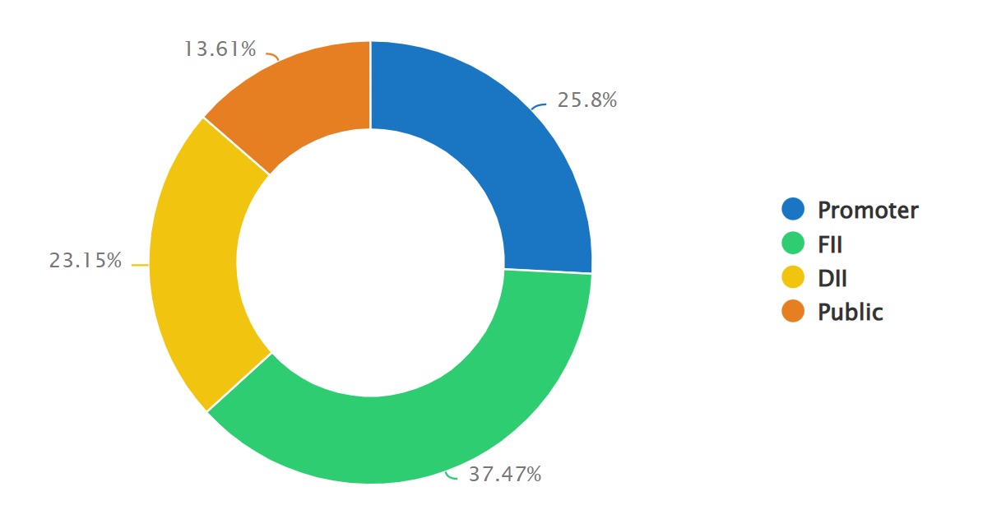

*Note: The DII includes both Mutual Fund holdings as well as Other domestic Institutions.

**Management of the company**

HDFC Bank’s leadership team brings together a diversity of talent and a wealth of experience. Guided by an experienced board and visionary managing director, the team steers the bank to new heights. As the world becomes increasingly digital, the management team is leading the bank to leadership in this emerging domain with innovative products and services.

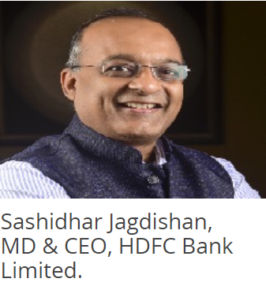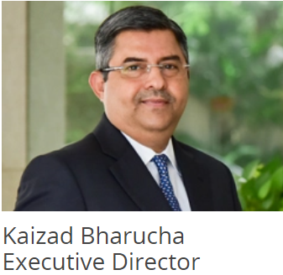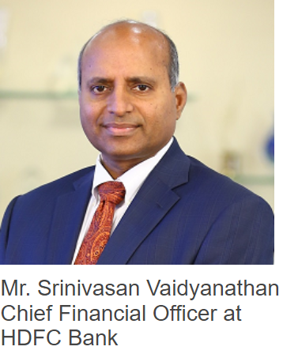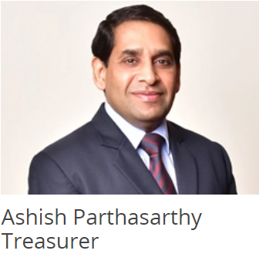

**Mr. Sashidhar Jagdishan** is the Managing Director & Chief Executive Officer of the Bank. He succeeds Mr Aditya Puri, the iconic Managing Director who led the bank since inception and retired on October 26, 2020. He joined HDFC Bank in 1996 and has played a critical role in its growth ever since. Starting as a manager in the Finance department, he's grown from strength to strength wearing different hats. In 1999, he became Business Head - Finance and in 2008, the Chief Financial Officer of the bank. He has led the finance function and played a pivotal role in aligning the organisation to achieve its strategic objectives over the years.He was adjudged Best CFO in the banking sector at the CNBC TV18 CFO Awards 2013-14.

**Mr. Kaizad M Bharucha** has been appointed as an Additional Director by the Board of Directors at its meeting held on December 24, 2013 and designated as an Executive Director, subject to the approval of the shareholders and the Reserve Bank of India. Mr. Bharucha holds a Bachelor's degree in Commerce (B.Com) from the University of Mumbai. Mr. Bharucha has been with the Bank since 1995.

**Mr. Srinivasan Vaidyanathan** is currently the Chief Financial Officer at HDFC Bank. In this role, he is responsible for finance and related processes at the Bank. Srinivasan joins the Bank from Citigroup, New York where he was Managing Director – Finance & Deputy Treasurer in the Institutional Clients Group, managing a Balance Sheet of over $ 1.3 trillion. Prior to this, he was the CFO in Citi Global Treasury, NY.

**Mr. Ashish Parthasarthy** holds a Bachelor of Engineering degree from the Karnataka Regional Engineering College and has a Post-Graduate Diploma in Management from the Indian Institute of Management, Bangalore. He has over 18 years of experience in the interest rate and currency markets and holds the position of Treasurer at the Bank.

**SWOT Analysis of the Company**

**Strengths of HDFC**

HDFC’s strengths are internal, good characteristics that are under the company’s control and the reason for its success. They are as follows.

* Large Network of Branches: HDFC Bank is India’s second-largest private banking sector, with 2,201 branches and 7,110 ATMs.
* Strong Consumer Banking: The ATM card issued by the bank is compatible with all domestic and international Visa/Master cards, Visa Electron/Maestro, and American Express cards. This is one of the reasons why HDFC cards are the most popular for shopping and online transactions.
* Higher Customer Satisfaction: When compared to other private banks, it has a high level of customer satisfaction.
* High Employee Retention Rate: The bank has a low employee turnover rate and is regarded as one of the best places to work in the private banking sector.
* Brand’s Goodwill: It has received numerous awards and recognition, including the title of “Best Bank” from various financial rating institutions such as Dun and Bradstreet, Financial Express, Euromoney Awards for Excellence, and Finance Asia Country Awards.

**Weaknesses Of HDFC**

Weaknesses are flaws that detract from one’s strengths. These are areas that the business may need to improve to remain competitive.

* No Rural Presence: HDFC Bank does not have a strong presence in rural areas, whereas ICICI Bank is expanding in the rural market.
* Limited Market Size: Unlike ICICI, HDFC lacks aggressive marketing strategies. The bank primarily serves high-end clients.
* Underperforming Sectors: Some of the bank’s product categories are underperforming and have limited market reach.
* Fluctuating Share Prices: The share price of the bank fluctuates frequently, causing investors to be uncertain.

**Opportunities of HDFC**

External aspects in the business environment that are likely to contribute to the success of the company are known as opportunities. Below mentioned are the opportunities of HDFC.

* Strong Fundamentals for Growth: As HDFC Bank has better asset quality parameters than government banks, profit growth is expected to increase.
* Increasing Corporate Banking Sector: Companies, both large and small and medium-sized, are expanding at a rapid pace. HDFC has a good reputation for keeping corporate salary accounts up to date.
* Efficient Debt Settlement: When compared to government banks, HDFC Bank’s bad debt portfolio has improved and its bad debt recovery rate is high.
* Foreign Markets: Because of its strong financial position, it has very good opportunities in foreign markets, with greater scope for acquisitions and strategic alliances.

**Threats of HDFC**

External elements over which the bank has no control are referred to as threats. The company needs to develop contingency plans for coping with them if they arise.

* Increasing NPA: The non-performing assets (NPA) of HDFC increased from 0.18 to 0.20 percent. Even though it is a minor difference, it is not a good sign for the bank’s financial health.
* New-Age Banks: The number of non-banking financial companies and new-age banks in India is growing.
* Lack of Growth: The HDFC is unable to increase its market share because ICICI poses a significant threat.
* Increasing Competition: Government banks are attempting to modernize to compete with private banks.
* Increasing Foreign Investments: The Reserve Bank of India has granted foreign banks permission to invest up to 74 percent of their assets in the Indian market.

**Competitive Analysis**

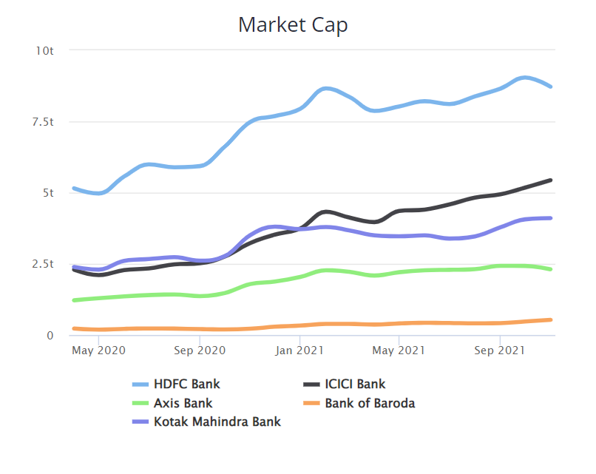HDFC is a large private bank, competing against other private banks such as:

* Axis Bank
* ICICI Bank
* Kotak Mahindra Bank
* Bank of Baroda

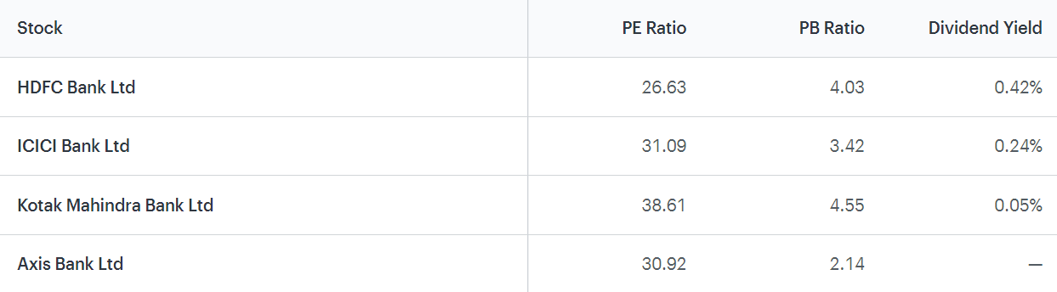

**Conclusion and way forward for the company**

**Key Takeaways from an Investment standpoint:**

* Current price is more than the intrinsic value
* Stock has been generating better return on equity than bank FD
* Stock doesn't offer attractive dividend returns
* Good time to consider, as stock is not in overbought zone
* Stock not in ASM/GSM lists and not a lot of promoters holding is pledged
* Stock is 1.55x as volatile as Nifty. Hence, it is viewed as a low-risk stock.

HDFC Group, a distinguished financial conglomerate, including performance in dwelling finance, investment, life, and non-life protection, asset superintendence, real estate funds, and teaching finance. The company is a great example of India’s advanced housing finance corporation. Yet, even as a modernised private bank with great customer servicing, they are suffering from multiple factors, such as a weakening economy and increasing competition from both traditional competitors and new-age digital banking.